***PAAREES PERFUMES***

***VERSACE***

***FOR MEN***

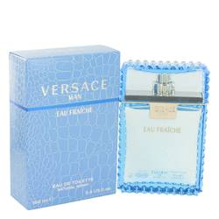

# 

***VERSACE MAN***

## *Description:*

Versace Man - For a clean fresh scent that will last throughout the day without overwhelming those around you, try Versace Man, a Versace cologne for men. With its notes of saffron, tobacco, cashmere wood, amber and pepper, this perfume from the design house of Versace is a masculine scent that is sure to keep your confidence high. Introduced in 2003, its distinctive scent will last for hours and is ideal when you're ready to head out for that special dinner.